# CS 255 System Design Document Template

## UML Diagrams

### UML Use Case Diagram

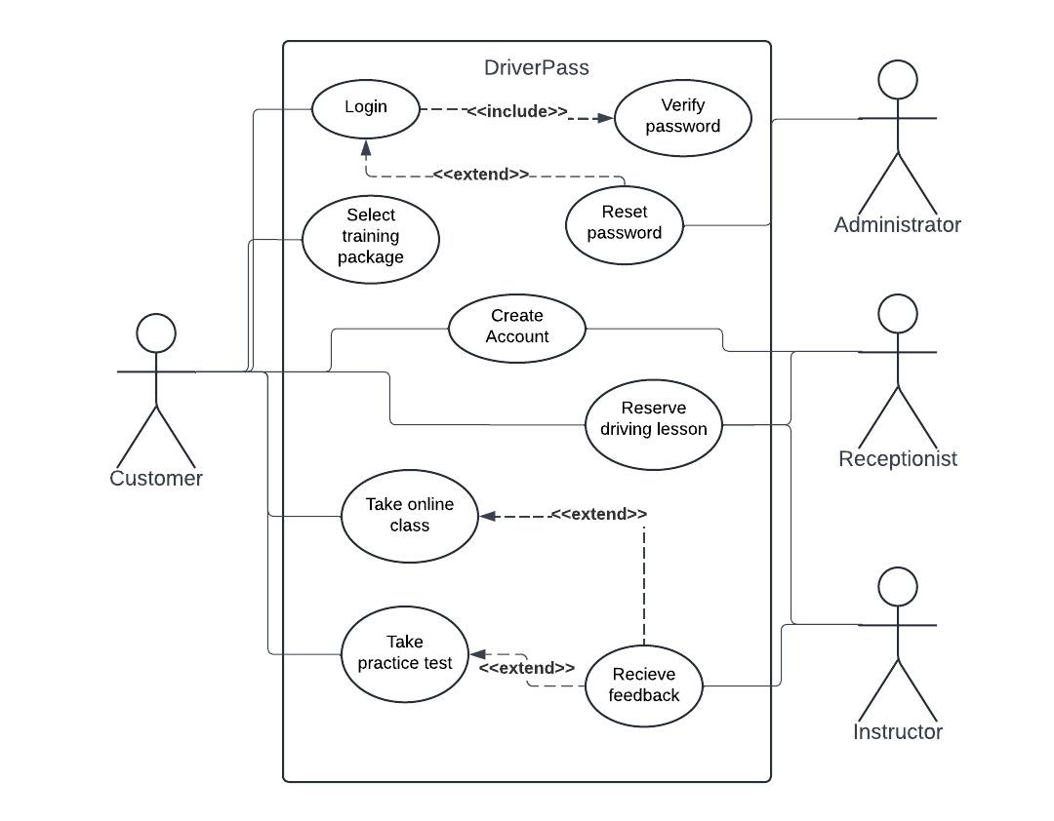

### UML Activity Diagram

### UML Sequence Diagram

### UML Class Diagram

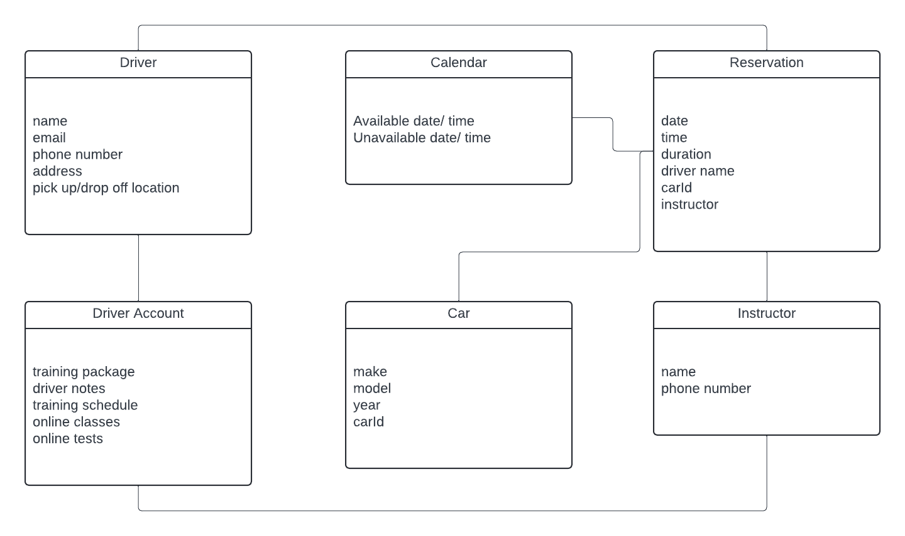

## Technical Requirements

Technical requirements would include accessibility, data storage, and security of the system. The system should be accessible to users on any web or mobile device that has a web browser and internet connection. Data storage is required for the system to store customer information and allow for easy access when needed. Security includes storing customer information privately and authenticating users when they login.